07_data_analysis 07june2011 16oct2011 (far below)

DF = 3
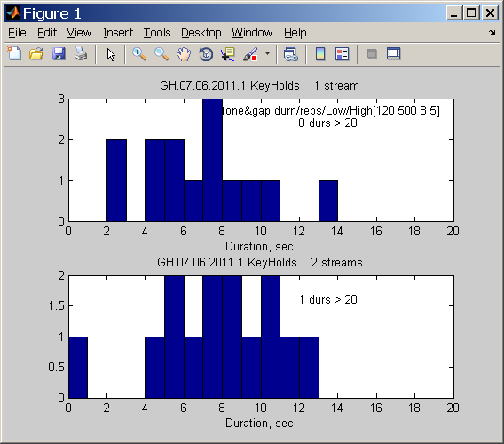

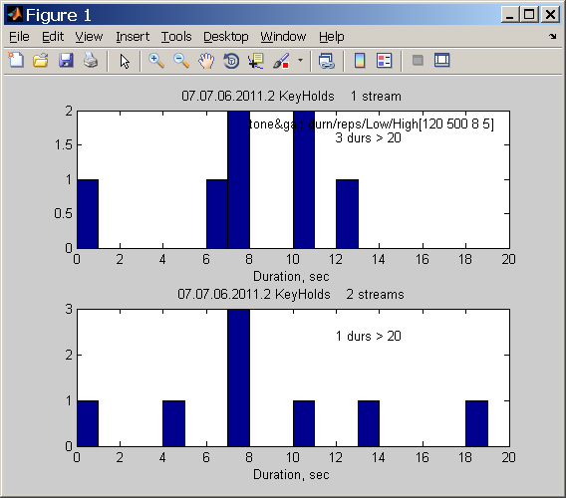

DF = 4

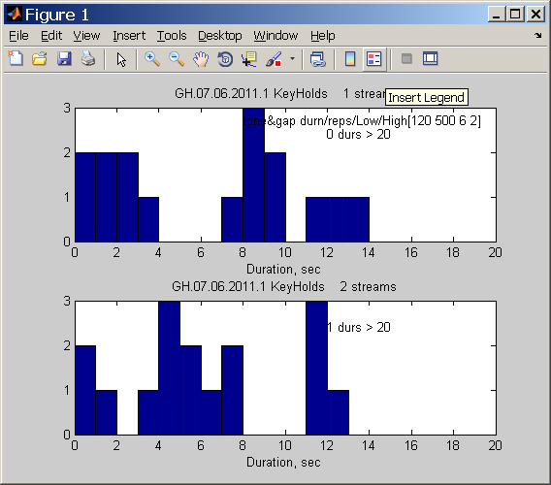

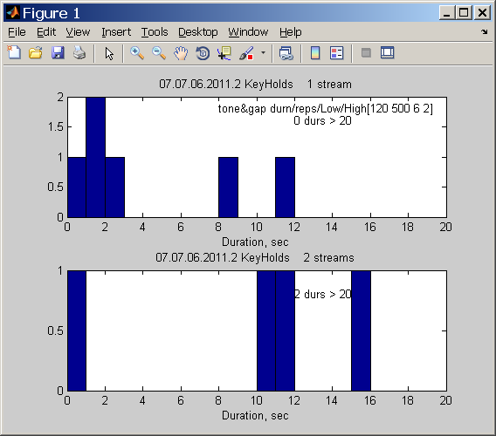

DF = 5

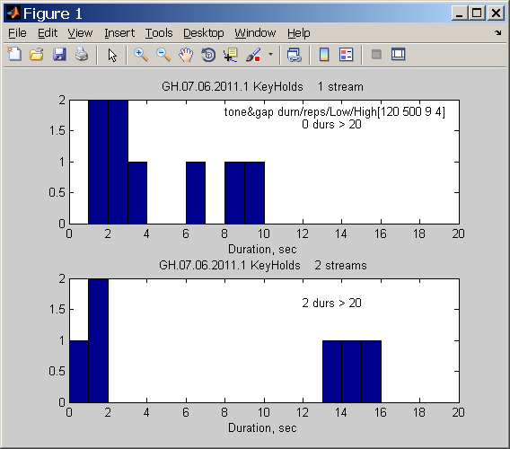

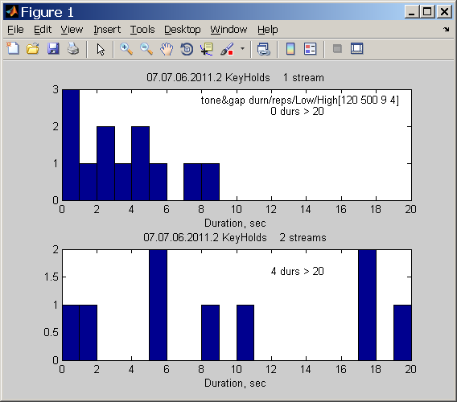

DF = 6

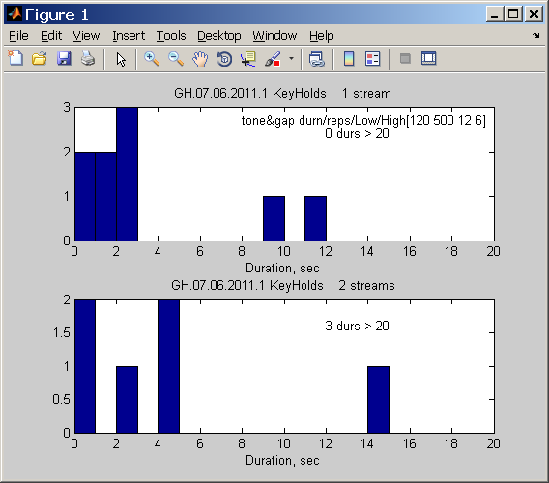

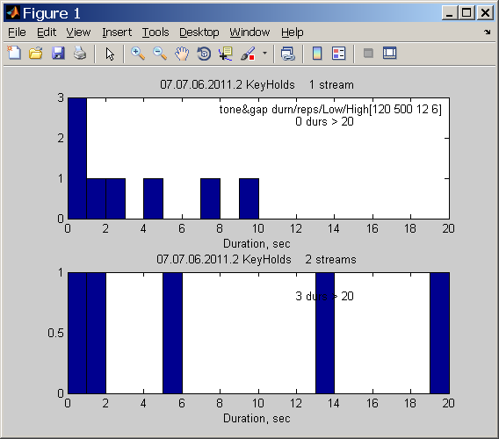

DF = 7

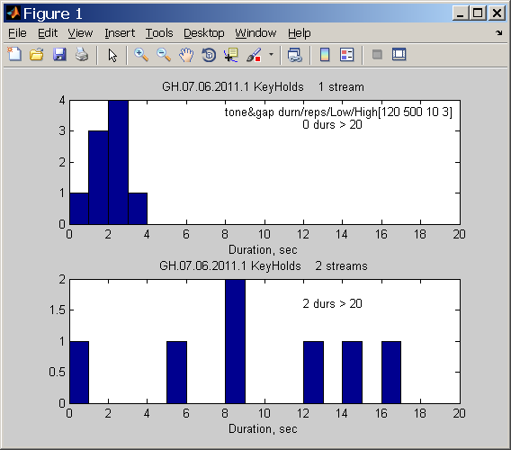

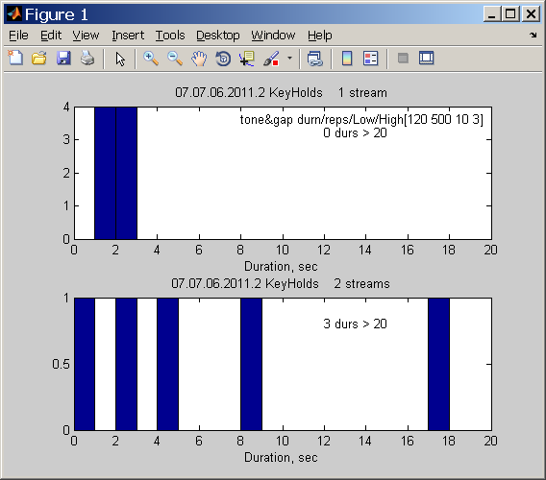

Summary data for 3 trials, analyzed on 16oct2011
Data from
07.07.06.2011.1 07.07.06.2011.2 07.14.10.2011_5DF_1trl

Each has 5 cond’ns (DF=3,…, 7) with 1 trial.
Here data for DF=4,5,6 are combined into
rnet07_3DFs

DF=4… 3 trials.
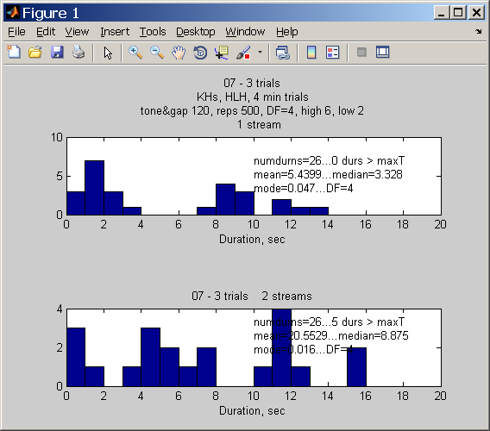
Stats for --07 - 3 trials...DF=4

26.0000 5.4399 3.3280 0.0470
26.0000 20.5529 8.8750 0.0160

DF=5… 3 trials.
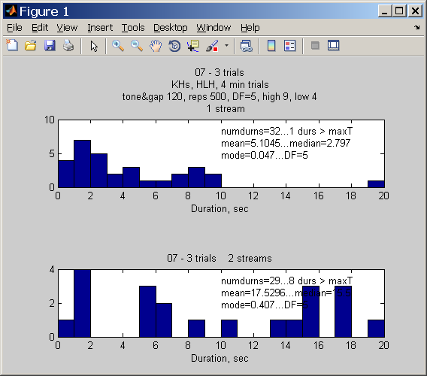

Stats for --07 - 3 trials...DF=5

32.0000 5.1045 2.7970 0.0470
29.0000 17.5296 15.5000 0.4070

DF=6… 3 trials
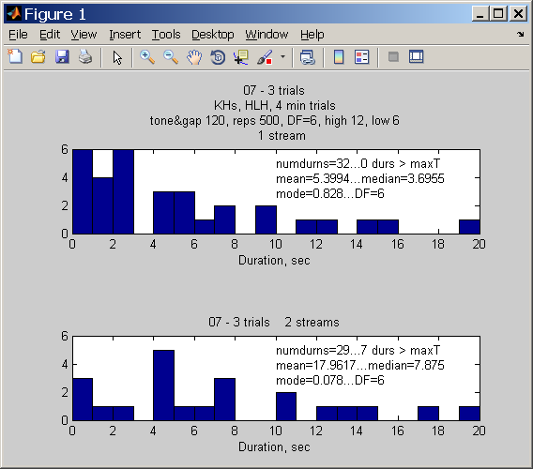

Stats for --07 - 3 trials...DF=6

32.0000 5.3994 3.6955 0.8280
29.0000 17.9617 7.8750 0.0780

